**PLASMA DONOR APPLICATION**

**PROJECT REPORT**

**TEAM ID: PNT2023TMID32253**

**TEAM LEADER :**

**GIRI S**-732119205016

**TEAM MEMBERS :**

**JOTHEESWARAN H**-732119205020

**NAVEENKUMAR M**-732119205032

**NITHESH KUMAR M**-732119205035

**NANDHA COLLEGE OF TECHNOLOGY**

**AFFILIATED BY ANNA UNIVERSITY**

**TABLE OF CONTENTS**

|  |  |
| --- | --- |
| **S NO** | **TITLE** |
| 1 | INTRODUCTION |
| 1.1 | PROJECT OVERVIEW |
| 1.2 | PURPOSE |
| 2 | LITERATURE SURVEY |
| 2.1 | EXISTING PROBLEM |
| 2.2 | PROBLEM STATEMENT DEFINITION |
| 3 | IDEATION AND PROPOSED SOLUTION |
| 3.1 | EMPATHY MAP CANVAS |
| 3.2 | IDEATION AND BRAINSTORMING |
| 3.3 | PROPOSED SOLUTION |
| 3.4 | PROBLEM SOLUTION FIX |
| 4 | REQUIREMENT ANALYSIS |
| 4.1 | FUNCTIONAL REQUIREMENTS |
| 4.2 | NON FUNCTIONAL REQUIREMENTS |
| 5 | PROJECT DESIGN |
| 5.1 | DATA FLOW DIAGRAMS |
| 5.2 | SOLUTION AND TECHNICAL ARCHITECTURE |
| 5.3 | USER STORIES |
| 6 | PROJECT PLANNING AND SCHEDULING |
| 6.1 | SPRINT PLANNING AND ESTIMATION |
| 6.2 | SPRINT DELIVERY SCHEDULE |
| 6.3 | REPORTS FROM JIRA |
| 7 | CODING AND SOLUTIONING |
| 7.1 | FEATURE 1 |
| 7.2 | FEATURE 2 |
| 7.3 | DATABASE SCHEMA |
| 8 | TESTING |
| 8.1 | TEST CASES |
| 8.2 | USER ACCEPTANCE TESTING |
| 9 | RESULTS |
| 9.1 | PERFORMANCE METERICES |
| 10 | ADVANTAGES&DISADVANTAGES |
| 11 | CONCLUSION |
| 12 | FUTURE SCOPE |
| 13 | APPENDIX |

**1. INTRODUCTION**

**1.1 PROJECT OVERVIEW**

* The person who wants to donate his/her plasma needs to register in the application.
* After that gives the basic information of donor

Like name, age, blood group, phone number and location etc .

* Patients can directly call the donor by taking his/her contact number from the application.
* The user can view the total active cases, recovered cases, vaccine canter hospital location and help line number.

**1.2 PURPOSE**

* + - To make easier for the **covid -**19 patients to get a plasma donor easily.
    - They have two types of users:

1. Plasma donors

2. Plasma acceptors

* The user also view near by location of hospital, vaccine center, and donor contact number.

**2. ITERATURE SURVEY**

**2.1 EXISTING PROBLEM**

* Location finding of donor to donate a plasma
* Searching of hospitals to find the plasma
* Searching of blood groups
* Blood centre finding of acceptor

**2.3 problem statement definition**

* It is difficult to find a plasma donor as everybody cannot donate a Plasma so the user can benefit to the website
* Plasma donor can easily donate our plasma.
* Plasma acceptor can easily find the plasma donor.
* The patients can directly call the donor by taking his/her contact number from the application.\

**3. IDEATION &PROPOSED SOLUTION**

**3.1 EMPATHY MAP CANVAS**

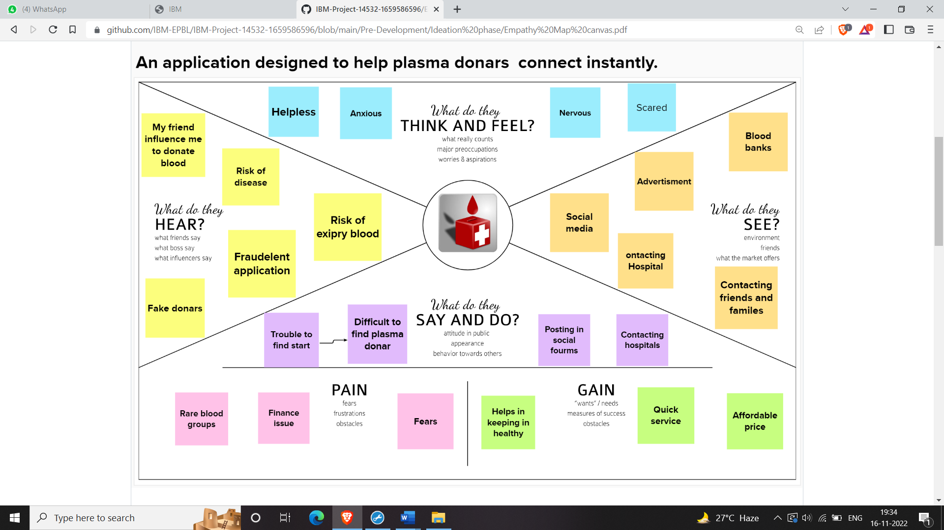

**3.2BRAINSTORMING DIAGRAM**

**s**